Step 1: Empathize - User Research
  - Stakeholder Identification & Justification
Stakeholder | Role |  | Decision Type | Analytics Need | Justification
Students / Occupants | Primary indoor users who spend the most time in classrooms and study areas |  | Comfort and safety decisions, whether to stay in a room or move | Simple air quality trend overview, room comparison to choose the best study space | Students are the most directly affected group. They need quick, digestible analytics to make immediate decisions about their environment.
Lecturers / Instructors | Classroom managers who conduct sessions in various rooms throughout the day |  | Ventilation adjustment decisions, whether to open windows, request fan activation, or change rooms | Quick air quality overview with time-slot comparison to identify patterns during lecture hours | Lecturers manage the classroom environment during sessions. They need analytics that help them understand which time periods or rooms consistently have poor air quality.
Facility / Maintenance Staff |  | Responsible for infrastructure oversight, ventilation systems, and room maintenance | Ventilation scheduling, preventive maintenance, and resource allocation | Historical trend analysis, room-to-room comparison, anomaly detection, and usage pattern data | Facility staff are the primary consumers of detailed analytics. They need historical data to identify recurring problems, schedule preventive maintenance, and justify resource allocation decisions.
Hostel warden /University Administration | Strategic planners responsible for energy efficiency, health compliance, and institutional policy |  | Energy efficiency optimization, health and safety compliance, and long-term infrastructure planning | Aggregated monthly/semester reports, compliance analytics, and energy usage patterns | Administration requires high-level aggregated analytics for strategic planning, budgeting, and ensuring compliance with indoor air quality standards.

  - User Research Methods:
A Survey and a informal questionaries were conducted to understand air quality awareness and ventilation behaviors.
- Survey & Observations
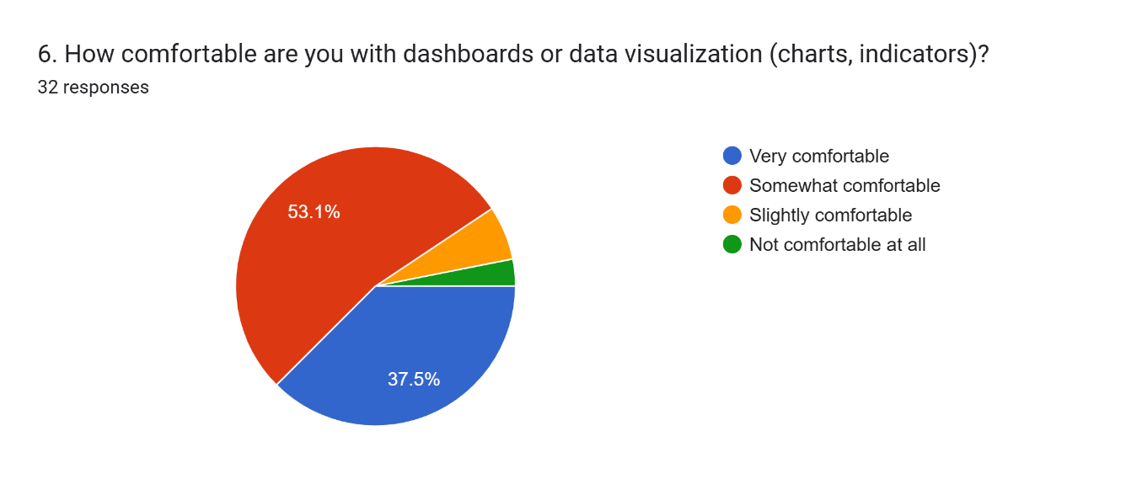

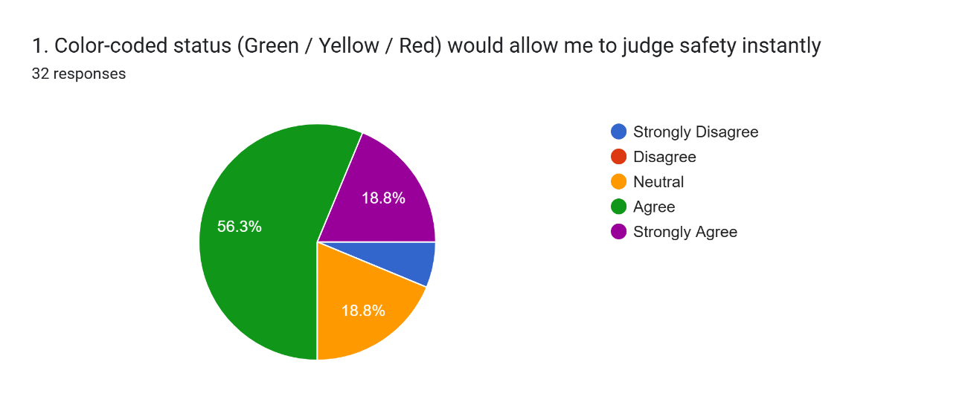

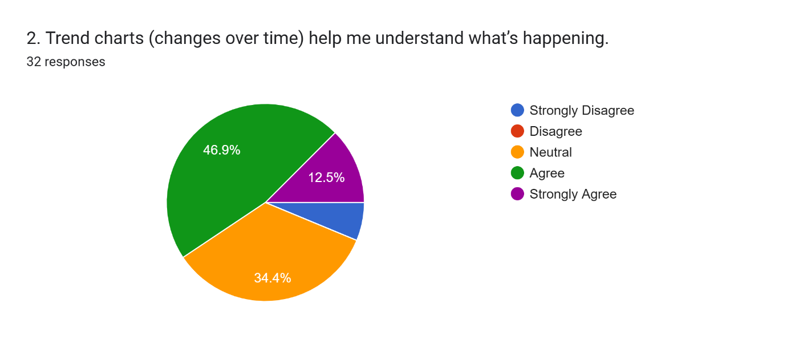

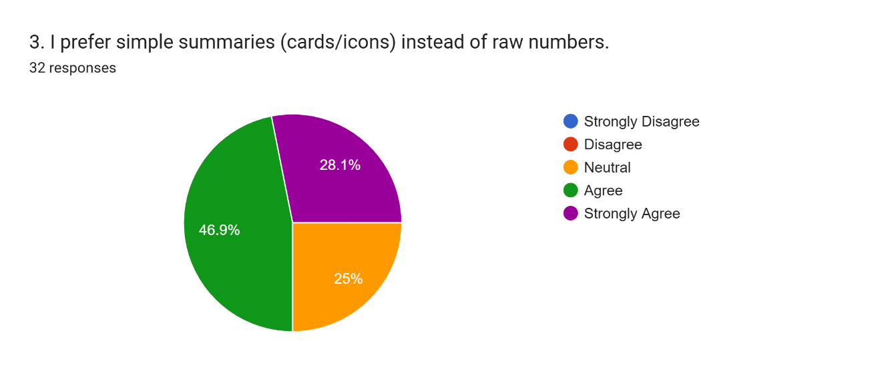

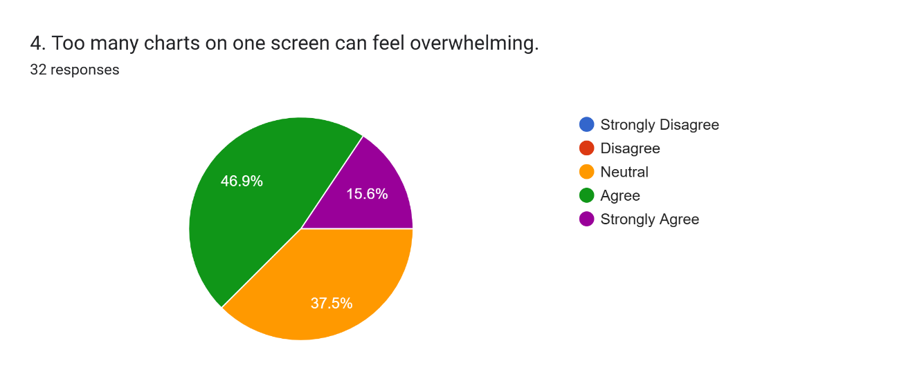

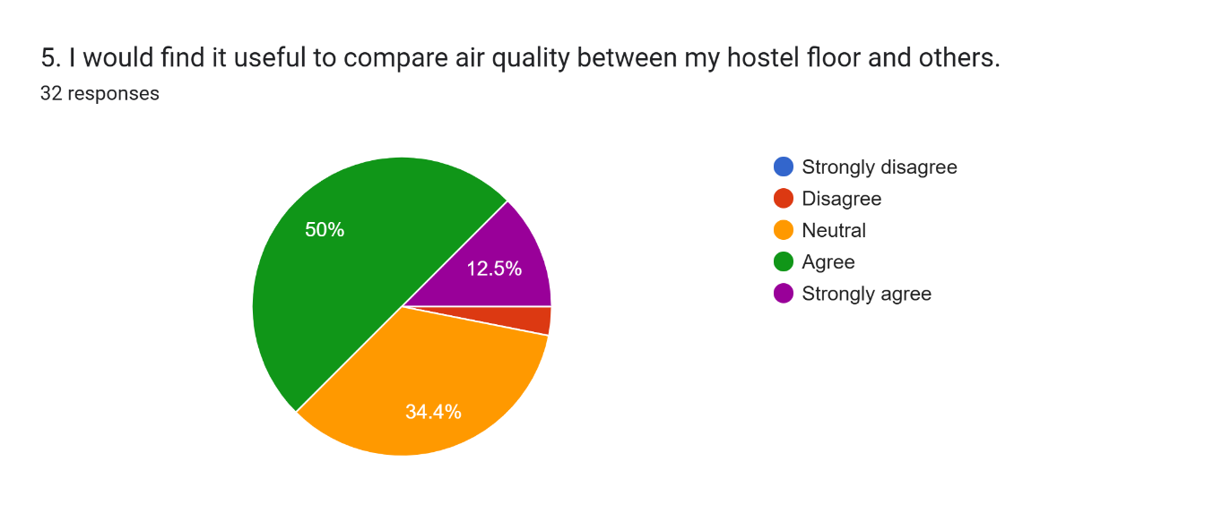

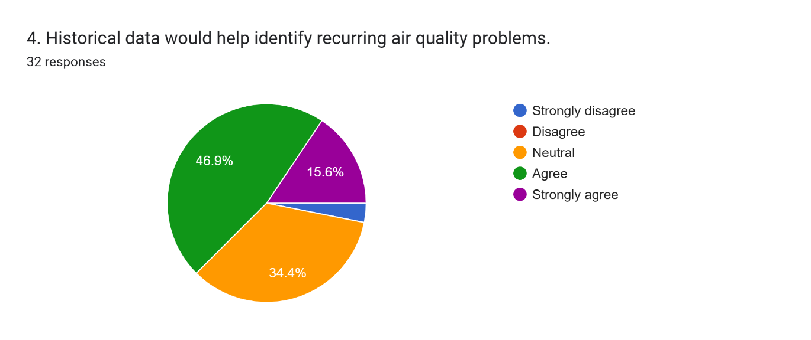

Observations:
- 43.8% would prefer visible air quality information over making assumptions demonstrating clear demand for the dashboard.
- Color-coded status is the most preferred visualization (65.7% agree/strongly agree) The analytics overview should lead with color-coded KPI cards for instant air quality recognition. This aligns with the pre-attentive processing principle, where color is processed before conscious thought.
- Trend charts are valued at 53.1% - Line charts for historical CO2, temperature, and humidity trends are validated as effective for this user base. However, 31.3% are neutral, suggesting trend charts should be placed in a secondary view (drill-down) rather than the primary overview.
- 59.4% prefer simple summaries (cards/icons) over raw numbers - The analytics entry point should use summary cards with visual indicators, not data tables. Raw numbers should only appear in detailed drill-down views.
- 53.1% find too many charts overwhelming - This is a critical finding. The analytics design must employ progressive disclosure (Overview first, zoom and filter, then details on demand). Avoid displaying all charts simultaneously.
- 43.8% find room/area comparison useful - Comparative analytics (room-to-room) should be included as a feature but not as the primary view, given the moderate demand.
- 62.6% agree that historical data helps identify recurring air quality problems - Users across all stakeholder groups recognize the value of historical trend analysis.

- Questionaries & observations
For students
  - Can you describe a recent situation where you felt uncomfortable in a classroom due to air quality? What did you do?
  - If you could see air quality data for the past week for every classroom, how would you use that information?
  - What is your chart literacy?
  - How many charts on a screen would you feel “too much”? What's your ideal?
  - Would you prefer to see a simple summary first and then click for details, or see everything at once?
For Lecturers
- Have you ever changed your teaching schedule or room due to air quality concerns? What information did you base that on?
- If you could see historical air quality patterns for your regular classrooms, what patterns would be most useful to know?
- Would you prefer analytics delivered as a dashboard you check, or as a periodic email/report?
- What level of detail do you need? Summary cards, detailed charts, or raw data tables?
Observations
- On chart literacy, three students said they could understand basic line charts and bar charts from academic exposure but preferred not to interpret them deeply.
- One student stated: "I understand line charts, but I don't want to analyze them - just tell me if the room is good or bad."
- Regarding chart density, all five students agreed that 3-4 charts maximum on a single screen was their comfort zone
- On visualization format, both preferred summary cards showing their rooms' status with the option to tap into a trend chart if needed.
- Regarding delivery, both preferred an on-demand dashboard over email reports.
- Summary cards with conditional drill-down to trend charts is the ideal format

1.3. Personas
1. University Student
Goals
- Quickly understand the current air quality status in a classroom.
- View visual trends of environmental conditions during study sessions.
- Identify whether poor air quality may affect focus and productivity.
Needs
- Simple visual indicators (color-coded air quality status).
- Easy-to-understand charts showing temperature, humidity, and CO₂ trends.
- Ability to quickly interpret the dashboard without technical knowledge.
- Lecturer
Goals
- Monitor classroom environmental conditions during lectures.
- Detect patterns where air quality worsens due to high occupancy.
- Make informed decisions regarding ventilation adjustments.
Needs
- Clear analytical insights showing CO₂ levels over time.
- Visualization of occupancy vs environmental conditions.
- Alerts supported by trend analysis rather than single readings.

  - Empathy maps

Step 2: Define – Problem Framing and Insight Synthesis
  - Analyze research data to identify:
User Needs
- Stakeholders need access to historical air quality trends to identify recurring patterns and shift from reactive to proactive decision-making.
Evidence - 62.6% of survey respondents agree historical data helps identify recurring problems)
- Analytics must serve four different stakeholder depth levels -from instant summaries to detailed trend analysis - without overwhelming any group.
Evidence - 53.1% find too many charts overwhelming. 59.4% prefer simple summaries over raw numbers. Interviews confirmed: students want "just tell me good or bad," lecturers want "show me the pattern for my room".
- Stakeholders need comparative analytics across rooms for space selection, maintenance prioritization, and infrastructure investment decisions.
Evidence - 43.8% find room comparison useful
- Users need to identify time-of-day and day-of-week air quality patterns to enable proactive scheduling and ventilation decisions
Evidence - lecturers identified time-based patterns as the most valuable analytical insight during the questionaries.
- Stakeholders need to understand how occupancy levels affect CO₂ concentration to inform ventilation capacity planning and occupancy policies.
- Facility staff need to compare air quality data before and after maintenance actions to verify repair effectiveness.
Pain points
- No historical data visibility.
- Invisible time-based patterns.
- Charts overwhelm.
- No maintenance feedback loop.
- Complaint-driven maintenance.
Decision-Support Scenarios
The proposed visual analytics dashboard supports stakeholders by transforming raw environmental sensor data into actionable insights. The following scenarios illustrate how data-driven analytics improves decision-making compared to traditional intuition-based approaches.
Decision Context | Without Analytics | With Visual Analytics
Students choosing a study room | Students choose rooms based on habit or availability and realize poor air quality only after experiencing discomfort. | Students check the dashboard and select the best room using the air quality score.
Lecturer requesting a classroom change | Lecturers rely on personal experience without supporting evidence. | Trend analysis shows poor air quality at certain times, enabling data-backed room change requests.
Facility staff prioritizing maintenance | Maintenance is usually based on complaints, leaving some issues unnoticed. | Room comparisons highlight recurring air quality problems, helping staff prioritize maintenance.
Facility staff verifying repairs | Repairs are assumed to be successful without data confirmation. | Environmental trends before and after maintenance confirm whether conditions improved.
Admin justifying ventilation budget | Budget requests rely on anecdotal observations. | Analytical reports provide measurable evidence of air quality issues to support budget proposals.
Admin setting occupancy policies | Room capacity is based on seat count rather than ventilation capability. | CO₂ vs occupancy analysis helps define safe occupancy limits.
Lecturer selecting lecture time slots | Lecturers assume certain times have poor air quality but cannot prove it. | Hourly trend analysis identifies time slots with better environmental conditions.

  - Formulate:
Problem Statements
- Absence of Historical Trend Visibility
stakeholders currently have no access to historical air quality data for classrooms. Research confirmed that 75% of users lack any data visibility. As a result, ventilation decisions are made reactively based on discomfort rather than environmental insights. Stakeholders need historical trend analytics to identify recurring air quality issues and support proactive decision-making.
- Inability to Compare Room Performance.
Users cannot compare air quality conditions across classrooms. Differences in environmental comfort between rooms remain anecdotal and unverified. Room-to-room comparison analytics are needed to help students select study spaces and enable facility staff to prioritize maintenance.
- Analytics Complexity vs User Capability Mismatch
Different stakeholders require different levels of analytical detail. Students prefer simple summaries, while facility staff require deeper analysis. The dashboard must use progressive disclosure providing simple visual summaries with optional drill-down analytics to support all user groups without overwhelming them.
- Lack of Evidence for Operational and Strategic Decisions
Maintenance and ventilation improvements are currently driven by complaints rather than environmental data. Facility staff and administrators lack analytical evidence to evaluate maintenance effectiveness or justify infrastructure investments. Historical trend analysis and reporting tools are needed to support data-driven decisions.
- Hidden Relationship Between Occupancy and Air Quality.
Stakeholders cannot see how room occupancy affects CO₂ levels and air quality. Without correlation insights, ventilation capacity limits and safe occupancy levels remain unclear. Occupancy-CO₂ analytics are needed to support evidence-based occupancy and ventilation policies.
User Stories
- Students / Occupants
- As a student, I want to see a simple color-coded air quality indicator so that I can understand room conditions without analyzing complex charts.
- As a student, I want to quickly view the air quality status of available study rooms so that I can choose a comfortable environment for studying.
- Lecturer (Air Quality Monitoring)
- As a lecturer, I want to monitor classroom air quality trends during lectures so that I can adjust ventilation when conditions deteriorate.
- As a lecturer, I want to see air quality patterns across different time slots so that I can identify periods when classroom conditions are poor.
- Facility Manager (Room Comparison)
- As a facility manager, I want to compare air quality conditions across rooms so that I can identify rooms that require maintenance or ventilation improvements.
- As a facility manager, I want to compare environmental conditions before and after maintenance so that I can confirm whether repairs improved air quality.
- Hostel owner (Strategic Planning)
- As a Hostel owner, I want to review summarized air quality analytics reports so that I can make data-driven decisions about ventilation investments and occupancy policies.
How Might We (HMW) Questions
How Might We Question | Related Insight
How might we help students instantly recognize which classrooms have safe air quality without needing to interpret complex charts? | Users prefer simple visual summaries such as color-coded indicators.
How might we present air quality analytics in a way that avoids overwhelming users with too many charts? | 53.1% of users reported that too many charts can be confusing.
How might we help students quickly compare multiple study rooms to select the best environment? | Users expressed interest in room comparison and ranking features.
How might we help lecturers identify air quality patterns across different lecture time slots? | Lecturers require time-based trend analysis to understand environmental conditions.
How might we help facility managers detect recurring air quality issues across rooms? | Facility staff need historical trend analysis and anomaly detection.
How might we help facility staff verify whether maintenance actions improve air quality? | Maintenance effectiveness currently lacks data verification.
How might we provide administrators with clear analytical evidence to support ventilation investment decisions? | Administration requires aggregated environmental reports for strategic planning.
How might we reveal the relationship between occupancy levels and air quality conditions? | Stakeholders currently cannot see correlations between occupancy and CO₂ levels.

  - Develop:
- User Journey maps
Students
Stage | User Action | Thoughts | Pain Points | Opportunity for Analytics
1. Need for Study Space | Students decide to find a quiet place to study | “Which room will be comfortable to study in?” | No information about environmental conditions | Dashboard overview showing room air quality status
2. Room Selection | Students choose a study room based on availability | “This room is usually okay.” | Decision based on habit rather than data | Room ranking based on-air quality score
3.Experience Room Conditions | Students stay in the room for some time | “The room feels stuffy.” | Poor air quality discovered only after discomfort | Real-time air quality indicator
4. Checking Environmental Data | Students open the dashboard to view conditions | “Is the air quality causing this?” | Raw data may be difficult to interpret | Color-coded summary cards with trend charts
5. Decision Making | Students decide whether to stay or move | “Maybe another room is better.” | No quick comparison between rooms | Room comparison analytics

Lecturer
Stage | User Action | Thoughts | Pain Points | Opportunity for Analytics
1. Lecture Preparation | Lecturer prepares for class in a scheduled room | “Will the classroom environment be comfortable?” | No environmental information before class | Pre-class air quality summary
2. During Lecture | Classroom becomes crowded during lecture | “The room feels warmer.” | Cannot confirm if air quality is deteriorating | Real-time CO₂ and temperature trends
3.Environmental Monitoring | Lecturer checks dashboard | “Is ventilation needed?” | Difficult to detect gradual changes | Trend visualization with alerts
4. Ventilation Decision | Lecturer adjusts ventilation or opens windows | “This should improve the conditions.” | No confirmation if ventilation is effective | Real-time feedback from analytics
5. Future Planning | Lecture reflects on classroom conditions | “Afternoon classes are always uncomfortable.” | Cannot verify patterns across weeks | Time-slot trend analysis

Facility Manager
Stage | User Action | Thoughts | Pain Points | Opportunity for Analytics
1. Routine Monitoring | Facility manager reviews building conditions | “Are there any rooms with environmental issues today?” | No centralized visibility of air quality across rooms | Dashboard overview showing room air quality status
2.Identifying Problem Areas | Manager checks environmental data for different rooms | “Which rooms consistently have poor air quality?” | Difficult to identify recurring problems without historical data | Historical trend charts for CO₂, temperature, and humidity
3.Comparing Room Performance | Manager compares environmental conditions across rooms | “Why does this room perform worse than others?” | No easy way to compare rooms using data | Room-to-room comparison analytics
4.Maintenance Decision | Manager schedules maintenance or ventilation checks | “This room may need maintenance or improved ventilation.” | Maintenance is often triggered only by complaints | Analytics highlighting rooms with frequent threshold violations
5. Verifying Maintenance Effectiveness | Manager checks environmental data after maintenance | “Did the repair actually improve conditions?” | No data to verify whether repairs were effective | Before-and-after trend comparison

- Task flow diagrams
Student – choosing a suitable room to study

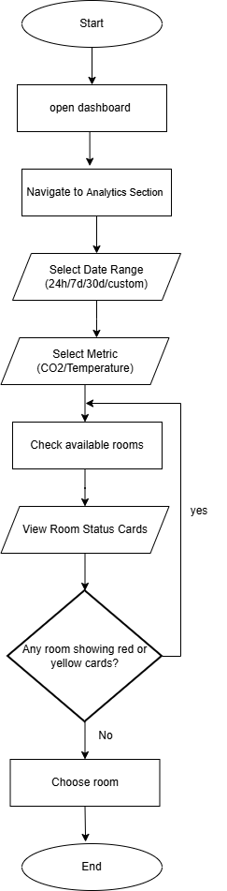

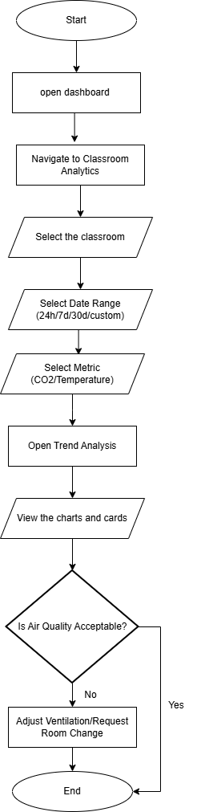
Lecturer - Identify poor air quality conditions during lectures.

Facility Manager - Identify rooms requiring maintenance and verify repair effectiveness.
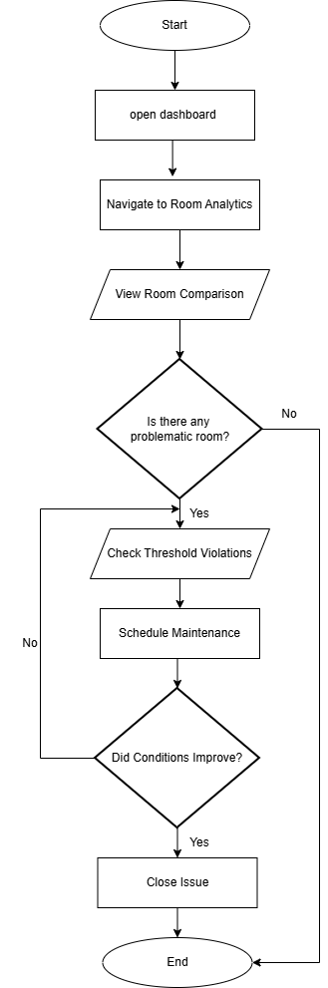

Step 3: Ideate – Dashboard Concept and Information Architecture
The proposed dashboard provides a visual analytics interface that enables stakeholders to monitor indoor environmental conditions and analyze patterns affecting air quality. The dashboard transforms raw IoT sensor data into interactive visualizations that support analytical reasoning and decision-making.
The design follows a progressive disclosure approach, where users first see simplified summaries and can then explore deeper analytical insights when required. This ensures that both non-technical users such as students and more analytical users such as facility managers can effectively interact with the system.
Information architecture
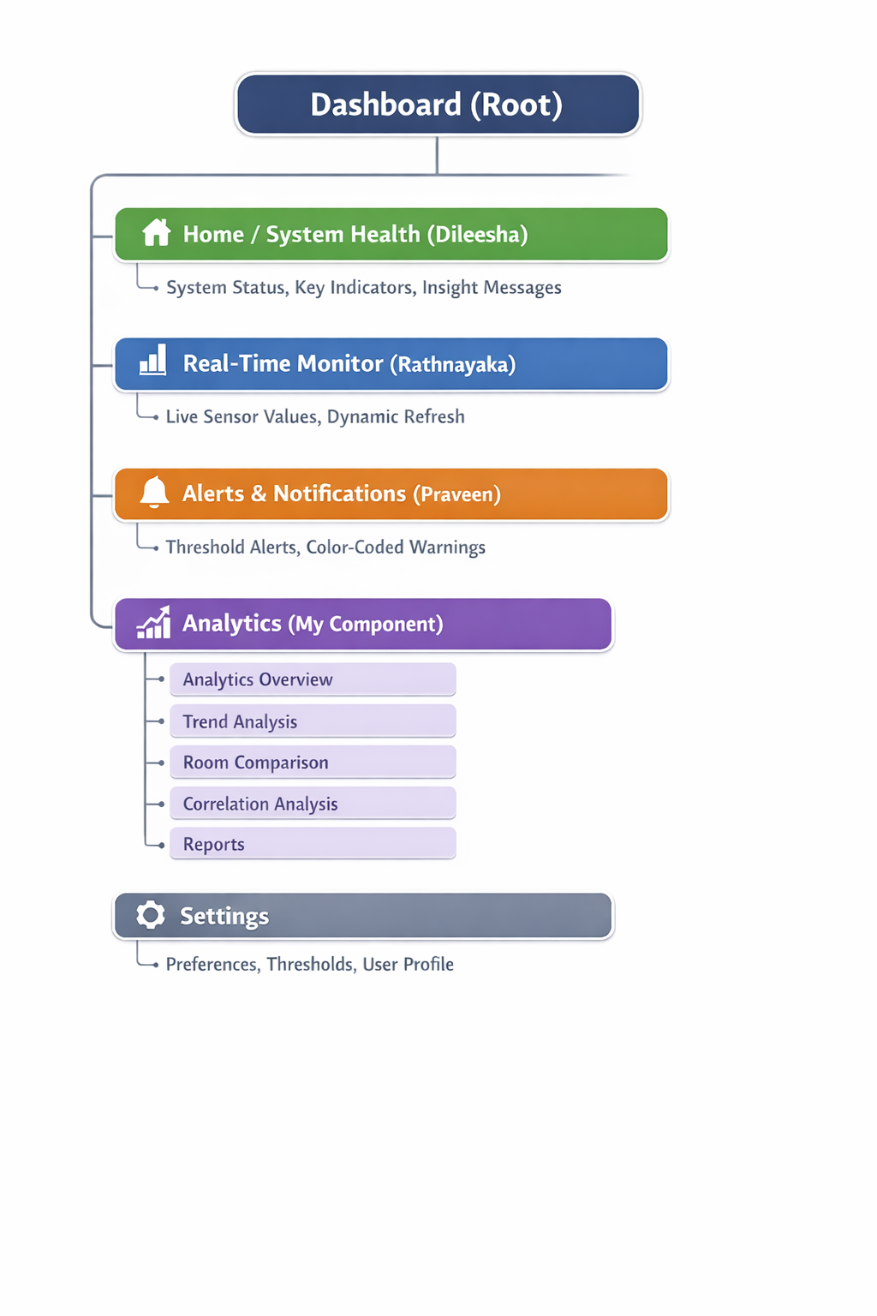

Navigation Structure
• The Analytics screen is accessed through the main navigation bar.
• Navigation bar: Home | Real-Time Monitor | Alerts | Analytics | Settings
• The Analytics overview cards are clickable - clicking a card opens the detailed analytics view.
• Time range filters (24h / 7d / 30d) allow users to view historical trends.
• Users can select different rooms to compare air quality performance.
Sketches and Low-Fidelity Wireframes
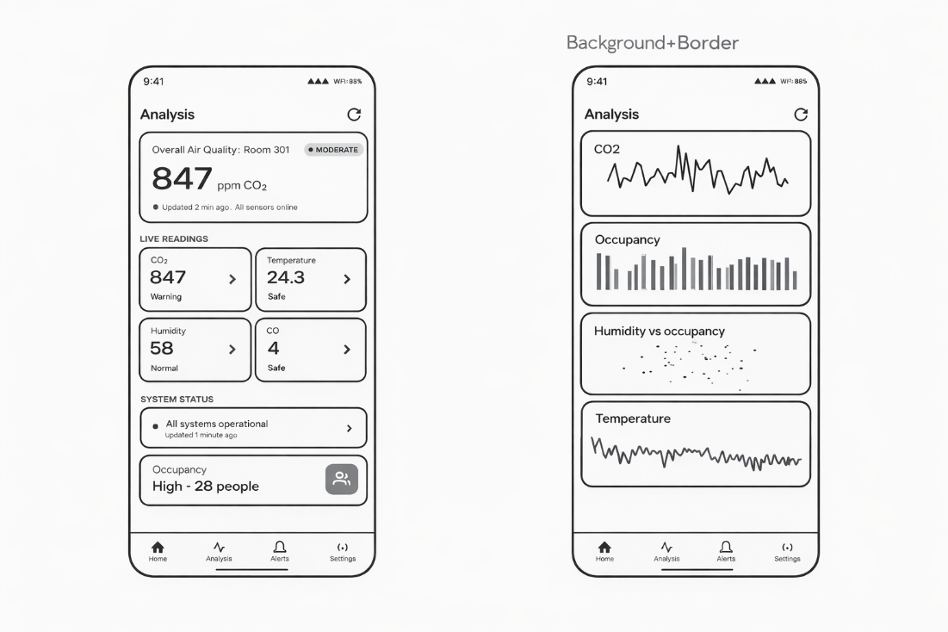
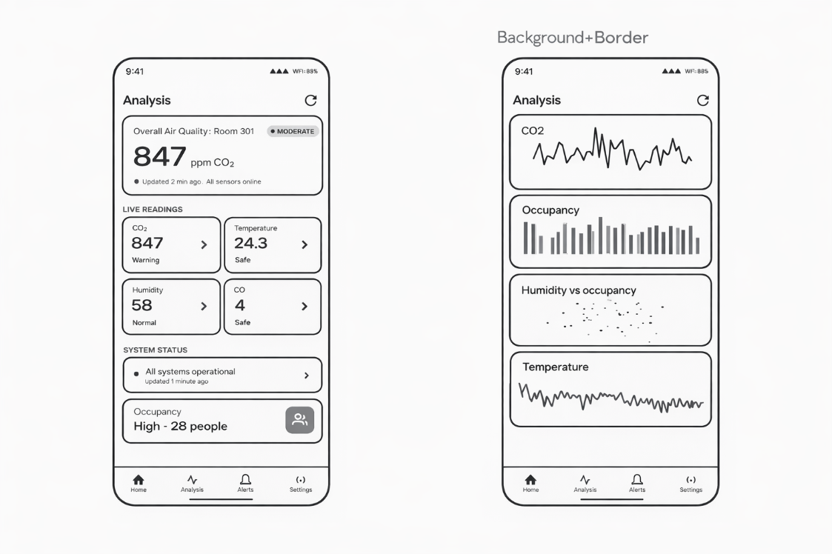

Visualization Types Selected for Analytics Screen
Component | Visualization Type | Justification
Air Quality Overview | Color-coded KPI cards | Provides quick understanding of overall air quality status
CO₂ & CO Levels | Line Chart | Shows time-based trends of gas concentration levels
Temperature | Line Chart | Helps monitor comfort stability over time
Humidity | Line Chart | Identify environmental imbalance patterns
Room Comparison | Bar Chart | Allows users to easily compare air quality across rooms
Occupancy | Indicator / Bar Chart | Displays room usage levels clearly
CO₂ vs Occupancy | Scatter Plot | Shows relationship between occupancy and CO₂ levels
Humidity vs Occupancy | Scatter Plot | Helps identify correlation between humidity and room usage

Interaction Mechanisms
Component | Interaction Mechanism | Description / Rationale
Air Quality KPI Card | Hover / Tap tooltip | Displays additional information such as CO₂ level, humidity, and temperature values when users interact with the card. Help users quickly understand environmental conditions.
CO₂ & CO Trend Chart | Hover data point | Hovering or tapping a point on the chart shows the exact gas concentration value and timestamp, helping users analyze environmental trends over time.
Temperature & Humidity Charts | Hover data point | Users can interact with the chart to view detailed environmental readings at specific times, supporting better understanding of comfort conditions.
Room Comparison Chart | Clickable chart elements | Selecting a room bar allows users to view detailed analytics for that specific room. Enables easier comparison between rooms.
Occupancy Indicator | Hover tooltip | Hovering displays the exact number of occupants and the current room capacity level. Help users understand usage patterns.
CO₂ vs Occupancy Scatter Plot | Hover tooltip | Hovering over data points reveals occupancy count and CO₂ level, helping users analyze correlations between occupancy and air quality.
Humidity vs Occupancy Scatter Plot | Hover tooltip | Provides detailed humidity values at different occupancy levels, enabling deeper environmental analysis.
Export Report Button | Click interaction | Clicking the button generates downloadable reports containing analytical insights for further analysis and documentation.

Step 4: Prototype – High-Fidelity Interactive Design
Prototype Tool - The high-fidelity prototype was designed using Figma.
Prototype Link - Prototypes
Design Decisions and Rationale
Color Palette
• Background: #000000 (pure black — used to create a high-contrast analytics environment that highlights visualizations and trend patterns clearly)
• Card Background: #1C1C1E (dark gray cards used to separate analytics panels such as charts, metrics, and room data)
• Primary Accent: #0A84FF (blue — used for navigation indicators, refresh buttons, and interactive analytics elements)
• Trend Indicator Red: #FF453A (used in the CO₂ trend chart to highlight fluctuations and possible risk patterns)
• Occupancy Green: #30D158 (used for occupancy bars and safe environmental indicators)
• Warning Yellow: #FFD60A (used for humidity-occupancy correlation points and moderate air quality alerts)
• Temperature Blue: #64D2FF (used for temperature trend visualization)
• Text Primary: #FFFFFF (high-contrast text for metric values and labels)
• Text Secondary: #8E8E93 (used for timestamps, descriptions, and secondary information)
Justification
A dark analytics interface improves data visualization contrast, allowing charts and trends to stand out clearly. The black background reduces eye strain and helps users quickly identify patterns in line charts, bar charts, and scatter plots.
Different colors are used for different environmental variables, allowing users to visually distinguish between CO₂ levels, occupancy patterns, temperature trends, and humidity correlations.
Typography
• Primary font: Inter (clean and modern sans-serif optimized for dashboard readability)
• Analytics KPI values: 40-48px Bold
Used for large air quality indicators such as CO₂ concentration.
• Chart titles: 16-18px Medium weight
Used for sections such as CO₂ trend, occupancy, humidity correlation.
• Room labels and metrics: 14px Regular
• Supporting information: 12px Secondary muted color
Justification
This typography hierarchy ensures that critical environmental indicators are immediately visible, while secondary information such as timestamps and room metadata remains readable but unobtrusive.
Visual Hierarchy (Gestalt Principles Applied)
- Proximity
Analytics charts related to environmental conditions are grouped together in cards (CO₂ trends, occupancy, humidity correlation). This grouping allows users to interpret related data patterns efficiently.
- Figure–Ground
Cards appear elevated against the dark background, making each visualization panel clearly distinguishable.
- Similarity
All analytics cards follow the same layout structure with chart titles, visualizations, and consistent spacing. This consistency allows users to quickly scan multiple charts.
- Hierarchy
The air quality summary panel appears at the top, followed by supporting environmental charts and deeper analytical visualizations.

UX Principles Applied
1. Pre-attentive Processing
• Color coding is used to instantly communicate environmental status.
• Trend colors allow users to recognize increasing or decreasing patterns without detailed analysis.
2. Fitts’s Law
• Room cards and analytics panels are designed as large interactive areas to improve touch interaction on mobile devices.
3. Nielsen Heuristics – Visibility of System Status
• Current air quality indicators and environmental metrics provide immediate feedback on room conditions.
4. Aesthetic and Minimalist Design
• Each screen contains a limited number of charts to avoid cognitive overload.
• Cards visually separate analytical information into digestible sections.
5. Error Prevention
• Color indicators help users quickly detect abnormal environmental conditions before problems escalate.
6. Accessibility
• Color indicators are supported with labels and values to ensure users can interpret data regardless of color perception differences.
7. Progressive Disclosure
• The dashboard first presents summary indicators, while deeper analysis such as correlation charts appears in the dedicated analytics screen.
Interaction Design
Room Selection Screen
Users select a classroom card to open the analytics view for that room.
Air Quality Overview Panel
Displays the current CO₂ level and air quality classification, allowing users to quickly assess environmental conditions.
Trend Charts
Line charts visualize changes in environmental conditions over time, helping users identify patterns.
Occupancy Chart
Bar charts represent room usage levels and allow users to analyze how occupancy affects air quality.
Correlation Chart
Scatter plots display the relationship between humidity and occupancy, helping users identify environmental dependencies.
Refresh Button
A refresh icon enables users to update analytics data and retrieve the latest sensor readings.
These interaction mechanisms ensure that users can navigate between rooms, monitor environmental conditions, and analyze patterns efficiently.

Responsive Design
Breakpoint | Layout
Desktop (≥1280px) | Multi-panel analytics dashboard displaying CO₂ trends, occupancy charts, temperature trends, and correlation charts simultaneously for deeper analysis.
Tablet (768–1279px) | Two-column layout shows air quality overview and trend charts on one side, with occupancy and correlation charts on the other side.
Mobile (<768px) | Single-column stacked layout where users first select a classroom, then view the analytics overview followed by scrollable trend charts and correlation visualizations.

